**VISVESVARAYA TECHNOLOGICAL UNIVERSITY**



MINI PROJECT REPORT ON

**“POWER GENERATION USING A WINDMILL”**

SUBMITTED BY:

**DIVYA SHREE R (1NH18EC711)**

**DEVIKA K (1NH18EC130)**

**SAHANA Y (1NH18EC131)**

**SHARANYA K N (1NH18EC747)**

Under the guidance of

**Dr.NAVEEN H**

Senior Assistatant Professor

Dept. of ECE, NHCE, Bengaluru.

# C:\Documents and Settings\Students\Local Settings\Temporary Internet Files\Content.Word\download (1).jpg

# NEW HORIZON COLLEGE OF ENGINEERING

(ISO-9001:2000 certified, Accredited by NAAC ‘A’, Autonomous college permanently affiliated to VTU)Outer Ring Road, Panathur Post, Near Marathalli, Bengaluru-560103

## NEW HORIZON COLLEGE OF ENGINEERING

## DEPARTMENT OF ELECTRONICS AND COMMUNICATION ENGINEERING



**CERTIFICATE**

Certified that the mini project work entitled “**Power generation using windmill**” carried out by **Divya Shree R(1NH18EC711), Devika K(1NH18EC130), Sahana Y(1NH18EC131), Sharanya K N(1NH18EC747),** bonafide students of Electronics and Communication Department , New Horizon College of Engineering, Bangalore.

The mini project report has been approved as it satisfies the academic requirements in respect of mini project work prescribed for the said degree.

Project Guide HOD ECE

------------------------- -------------------------

**External Viva**

Name of Examiner Signature with Date

1.

2.

**ACKNOWLEDGEMENT**

The satisfaction that accompany the successful completion of any task would be, but impossible without the mention of the people who made it possible, whose constant guidance and encouragement helped us succeed.

We thank **Dr. Mohan Manghnani**, Chairman of **New Horizon Educational Institution**, for providing necessary infrastructure and creating good environment.

We also record here the constant encouragement and facilities extended to us by **Dr. Manjunatha**, Principal, NHCE and **Dr. Sanjeev Sharma**, head of the department of Electronics and Communication Engineering. We extend sincere gratitude to them.

We sincerely acknowledge the encouragement, timely help and guidance to us by our beloved

guide **Dr. Naveen H** to complete the project within stipulated time successfully.

Finally, a note of thanks to the teaching and non-teaching staff of electronics and communication department for their co-operation extended to us, who helped us directly or indirectly in this successful completion of mini project.

**Divya Shree R(1NH18EC711)**

**Devika K(1NH18EC130)**

**Sahana Y(1NH18EC131)**

**Sharanya K N(1NH18EC747)**

**TABLE OF CONTENTS**

ABSTRACT

**CHAPTER 1**

INTRODUCTION……………….……………………………………………7

**CHAPTER 2**

LITERATURE SURVEY……………………….…………………………….8

**CHAPTER 3**

PROPOSED METHODOLOGY……………………………………………...10

**CHAPTER 4**

PROJECT DESCRIPTION ………………………………………………….14

4.1 HARDWARE DESCRIPTION………………………………….…….….14

4.2 SOFTWARE DESCRIPTION…………….…………………........………35

**CHAPTER 5**

RESULTS AND DISCUSSION……………………………………………39

**CHAPTER 6**

CONCLUSION AND FUTURE SCOPE ……………………....……………40

REFERENCES…………………………………………....………………….41

APPENDIX…………………………………………………………………..42

**LIST OF FIGURES**

|  |  |  |  |
| --- | --- | --- | --- |
| **SL**  **No** | **FIGURE**  **No** | **FIGURE DESCRIPTION** | **Page**  **No** |
| 1 | 1 | Block diagram | 10 |
| 2 | 1.1 | Wind turbine | 11 |
| 3 | 1(a) | D.C Motor | 13 |
| 4 | 1(b) | D.C Motor(Internal part) | 15 |
| 5 | 2(a) | Arduino UNO | 16 |
| 6 | 3(a) | LCD 16*2 | 18 |
| 7 | 3(b) | LCD Pin diagram | 20 |
| 8 | 4(a) | Current Sensor- ACS712 | 20 |
| 9 | 4(b) | Current sensor pin diagram | 22 |
| 10 | 5(a) | 5K Ohms Potentiometer | 22 |
| 11 | 6(a) | Arduino Software | 34 |
| 12 | 6(b) | Arduino Software (description). | 36 |

ABSTRACT

The Wind Turbine Phone Charger provides up to 15 watts of battery power, which can charge most portable electronic devices through a USB port. The turbine itself is a two-stage savonius with offset blades to capture wind from all sides. The blades are connected to a shaft that rotates the gearbox, which accelerates the generator. A permanent magnet DC machine acts as a generator that produces an unregulated voltage. This voltage is transmitted via power electronics and a USB-C interface that provides 5 V to the battery. The microcontroller controls the output power of the generator and on the basis of this calculates the wind speed. These two values are displayed on the LCD. In addition, the microcontroller supplies 5 V to many microcircuits in the power electronics system. All individual parts work correctly, but combining all parts is problematic.

**CHAPTER 1**

INTRODUCTION

Renewable energy has been steadily rising in use for many years. There are solar and wind farms that harvest hundreds of megawatts of daily. This renewable technology is also growing on the smaller scale with houses having their own solar panels and even external phone batteries can be connected to solar panels. However, solar can only produce when there is sunlight and battery packs have only so much storage. There has been little exploration on utilizing small scale wind power and power supplies for portable devices will be in high demand for the foreseeable future. The wind turbine phone charger harnesses wind to provide power when solar and battery packs may fail as well as prove the viability of expanding wind power utilization to the small-scale.

The main blocks of the project are the turbine, power electronics, and microcontroller. The subsections of these blocks can be seen in Figure 1. The turbine block, consisting of the rotor and the generator, functions to convert wind power with speeds between 5-12 m/s to electric power with voltages ranging 0 to 18V. The specific type of wind turbine we chose remained consistent throughout the project, where we had to make some additional changes to certain. Next, the turbine block delivers power to the power electronics block. The power electronics block is made of a DC/DC converter and a control unit. The main function of the power electronics block is to take whatever voltage the generator supplies and output a constant 5V. The power electronics went through a few changes over the course of design and building. For example, the converter began as AC/DC rectifier and a DC/DC converter since we initially believed the generator would output AC. Next, the microcontroller is connected to all other blocks. It reads voltage from the generator and computes the wind speed both of which are displayed on a 2x16 LCD screen. Additionally, it takes power from the battery and distributes it to parts of the control circuit that need low power 5V. There are no significant changes to the overall microcontroller block from its original block. Lastly, the auxiliary blocks consist of the battery and the phone. While the battery is necessary, it can be swapped for different ones and was not something we designed same goes for the phone. In short, the turbine can harness wind energy and output 2.5-15W to a battery at 5V.

**CHAPTER 2**

LITERATURE SURVEY

Wind farms are created when multiple wind turbines are placed in the same location for the purpose of generating large amounts of electric power. Due to rising energy prices and the resultant search for alternatives, there are now thousands of wind farms in many countries around the world. There is still a lot of controversy surrounding the pros and cons of wind power and its local impact. The articles listed on this page explore news and information about wind farms.

The three-bladed rotor proliferates and typically has a separate front bearing, with low speed shaft connected to a gearbox that provides an output speed suitable for the most popular four-pole (or two -pole) generators. This general architecture commonly, with the largest wind turbines, the blade pitch will be varied continuously under active control to regulate power in higher operational wind speeds. Support structures are most commonly tubular steel towers tapering in some way, both in metal wall thickness and in diameter from tower base to tower top. Concrete towers, concrete bases with steel upper sections and lattice towers, are also used but are much less prevalent. Tower height is rather site specific and turbines are commonly available with three or more tower height options.

The author Fujin Deng used a variable speed wind turbine, where multiple permanent magnet synchronous generators (MPMSGs) drive-train configuration is employed in the wind turbine. A cascaded multilevel converter interface based on the MPMSGs is developed to synthesize a desired high ac sinusoidal output voltage, which could be directly connected to the grids. What is more, such arrangement has been made so that the output ac voltage having a selected phase angle difference among the stator windings of multiple generators. The multiple pole Permanent magnet synchronous generators are cost effective duo to multiple pole it induces eddy current and Hysteresis losses so it is reduced by proposed method.

future work includes better integration of the parts, reducing the weight of the turbine as well as increasing the efficiencies of the modules that make up the system. The weight of the turbine could be reduced by implementing a smaller mechanical design. There are much lighter parts available and the gearbox could easily be refined to take up less space, create less drag, and be lighter. The power electronics could be made more efficient since some parts ended up oversized. Additionally, safety features like braking and waterproofing could be incorporated to make the portable wind turbine more versatile.

**CHAPTER 3**

EXISTISING SYSTEM AND PROBLEM STATEMENT

### **Wind energy conversion system**

A wind energy conversion system (WECS) is powered by wind energy and generates mechanical energy that sends energy to the electrical generator for making electricity. shows the [interconnection](https://www.sciencedirect.com/topics/engineering/interconnection) of a WECS. The generator of the [wind turbine](https://www.sciencedirect.com/topics/engineering/wind-turbines) can be a permanent magnet [synchronous generator](https://www.sciencedirect.com/topics/engineering/synchronous-generator) (PMSG), doubly fed induction generator, induction generator, synchronous generator, etc. Wind energy acquired from the wind turbine is sent to the generator. To achieve maximum power from the WECS, the [rotational speed](https://www.sciencedirect.com/topics/engineering/rotational-speed) of the generator is controlled by a [pulse width modulation](https://www.sciencedirect.com/topics/engineering/pulse-width-modulation) converter. The output power of the generator is supplied to the grid through a generator-side converter and a grid-side [inverter](https://www.sciencedirect.com/topics/engineering/inverter). A [wind farm](https://www.sciencedirect.com/topics/engineering/wind-farms) can be distributed in onshore, offshore, seashore, or hilly areas. The WECS might be the most promising DG for future SG.

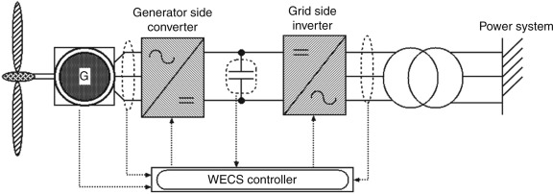

Wind energy is an alternative to fossil fuels, it is plentiful, renewable, widely distributed, clean, low cost, produces no emissions during operation, and uses a tiny land area. The effects on the environment are generally less problematic than those from other conventional power sources. Due to the [variable wind speed](https://www.sciencedirect.com/topics/engineering/variable-wind-speed), the output power of the WECS fluctuates and may create a frequency deviation of the power grid. To solve this problem, much research has already been conducted.

The world wind energy association (WWEA) published the key statistics of the World Wind Energy Report 2013.

The world wind energy capacity reached 318.5 GW by end of 2013 (this was 282.2 GW in 2012). In total, 103 countries are today using wind power on commercial basis. China was still by far the leading wind market with a new capacity of 16 GW and a total capacity of 91.3 GW. Wind power contributes close to 4% of the global electricity demand. For the year 2020, the WWEA predicts a wind capacity of more than 700 GW

PROBLEM STATEMENT: Generation of current from a renewable energy

**CHAPTER 4**

PROPOSED METHODOLOGY

PRINCIPLE:

The principle of operation of a windmill is the generation of energy by natural forces (air). The windmill blades rotate due to the wind and strike. Rotating blades transfer energy to the generator.

Then the mechanical energy is converted into electrical energy by a DC generator. The voltage generated by the DC generator is measured by the voltage sensor, and the current generated is measured by the current sensor. According to the wind speed, the oscillating voltage is converted into a DC voltage boosting unit. The output voltage is measured by a voltage sensor. On the other hand, the output current of the unit is measured by a current sensor. The output voltage is then transferred to the battery for charging.

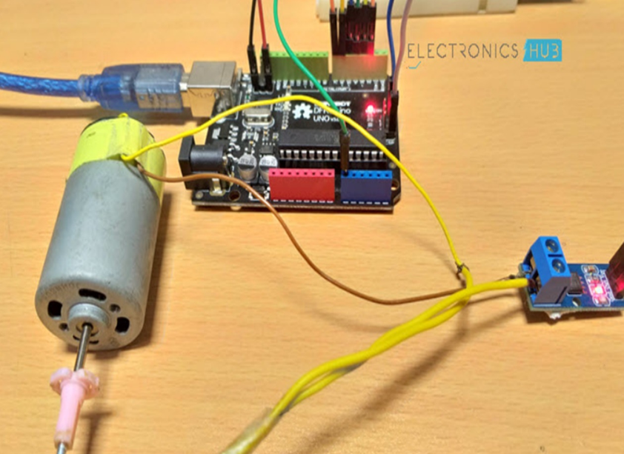

**BLOCK DIAGRAM**

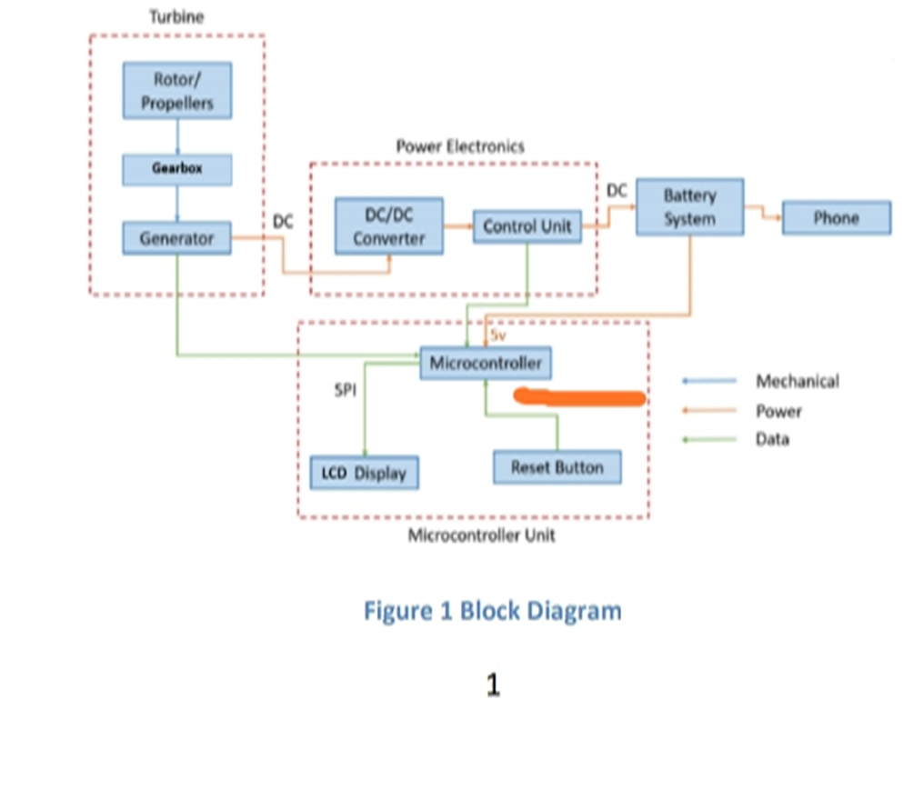

WORKING

The main parts of the project are turbines, electronic power supplies and precision controllers.

**TURBINE**

The turbine is the first step in the propulsion system, as it converts wind energy into mechanical energy. The body of the turbine consists of a rotor and a generator, and the principle of its operation is to convert wind energy at a speed ranging from 5-12 m / s to electrical energy with a voltage range from 0 to 18 volts. Throughout the project, the specific types of wind turbines we selected were consistent, so we had to make other changes to each other. Then the turbine block provides energy for the electronic energy block.

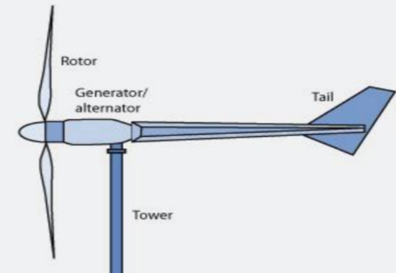

**Fig 1.1**

POWER ELECTRONICS

The generator will generate unregulated DC power, which must be adjusted to the appropriate output voltage of the battery pack through the transformer. The DC will first pass through the input filter. The transformer will then act as a buck or push depending on whether the output voltage is above or below the output voltage. Too small waves must be output to match commercial equipment.

The main function of the control unit is to ensure that our voltage output does not exceed the battery value of 5V. Current sensors are important devices in power calculation and applications. It measures current through a device or circuit and produces an appropriate signal that is proportional to the measured current. Usually, the output signal is analog voltage.

ASC712 depends on the effect of the hall. The copper strip connects IP + and IP pins internally. When current flows through the copper conductor, a magnetic field detected by the Hall Effect Sensor is created. The Hall Effect Sensor converts the magnetic field into a suitable voltage. In this way, the inputs and outputs are completely isolated.

The ASC712 current sensor board screw ends are connected straight to the motor. Then connect the VCC, GND, and OUT of ASC712 board to + 5V, GND, A0 from Arduino. Now, to view the results, connect the 16 x 2 LCD screen to Arduino. The RS, E and D4-D7 pins are connected to Arduino I / O 7 to 2 digital pins.

10KΩ POT is connected to LCD pin 3, VCC and GND are connected to + 5V and GND.

ARDUINO

From the flowchart above we can see that electricity (voltage and current) from wind turbine generators will be flowed to the Arduino. Arduino will then detect the amount of voltage and current voltage and current sensors. The amount of voltage and current will be display in an LCD screen.

Arduino is a single-plate microcontroller designed to create interactive applications of objects or environments easier. the fabric consists of associate open supply hardware board designed round the 8-bit Atmel AVR controller or the 32-bit Atmel ARM. The boot program is pre-programmed into a built-in microcontroller chip, and also the boot loader permits you to transfer the program to the microcontroller memory while not the requirement for a chip (device) developer.

We can see that the electricity (voltage and current) from the wind turbines can flow to Arduino. After that, Arduino will discover the voltage and current with this current sensor. Voltage and current are going to be displayed on the digital display screen.

CHARGING OF PHONE

The current produced by the wind generator is given to a DC/DC booster or a voltage regulator. This in turn is given to a USB jack which is connected to a mobile phone.

Therefore, when the windmill starts rotating, charging of mobile phone takes place.

**CHAPTER 5**

PROJECT DESCRIPTION

**A. HARDWARE DESCRIPTION:**

**1.DC MOTOR**

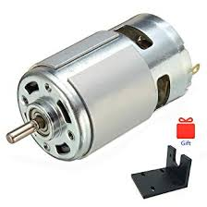

**FIG 1 (a): DC MOTOR**

DC motor is any type of rotary motor that converts DC electric energy into mechanical energy. The most common type depends on the force generated by the magnetic field. Almost all types of DC motors have some internal electromechanical or electronic mechanisms that can change the current direction of some motors periodically.

Top of Form

DC motors are the first widely used drive shape because they can be powered by DC power distribution systems. By using variable voltage to supply power or by changing the current intensity in excitation winding, the DC motor speed can be controlled in a wide range. Small DC motors are used in tools, games and equipment. The general-purpose motor can be run under direct current, but it is a light brush drive for portable electric tools and equipment. These great capital engines are currently used to drive electric cars, elevators and elevators, and for the movement of steel mills. The advent of electronic power supplies makes it possible to replace DC motors with AC motors in many applications.

The coil through which the current is flowing creates an electromagnetic field aligned with the centre of the coil. The direction and size of the magnetic field generated by the coil can vary depending on the direction and size of the current flowing through the coil.

This simple DC motor has a fixed set of magnets in the stator and one or more insulated wire windings in the motor, which are wrapped around a soft iron core that collects the magnetic field. The winding is usually winded in many turns on the core of the iron, and there may be many parallel currents on a large motor. The end of the wire winding is connected to the transformer. The inverter allows each armature coil to be activated in turn, and the rotary coil is connected to an external power source through the brushes. (Brushless DC motors contain electronics that can activate and deactivate DC current in each coil, and do not contain brushes.)

The total amount of current transmitted to the coil, coil size, and the strength of the electromagnetic field surrounding the generated object. The order of activation or deactivation of a specific winding determines the direction to which the effective electromagnetic field indicates. By turning the coil on and off sequentially, a rotating magnetic field can be created. These rotating magnetic fields interact with the magnetic fields of the magnet (permanent or electromagnetic magnet) in the stator of the motor (stator) to generate torque in the motor that forces it to spin. In some designs of DC motors, the fixed magnetic field uses the electromagnetic part to generate its magnetic field, which can better control the motor.

At high power (voltage) levels, Direct current motors are cooled by using air as a medium.

Different numbers of fixed magnetic fields, engine parts and connections provide different speed / torque control properties. The DC motor speed can be controlled by changing the voltage applied to the rebar. By introducing variable resistance into the motor circuit or the excitation circuit, the speed control can be performed. Modern DC motors are usually controlled by an electronic power system that regulates the voltage by "cutting" the DC in an active low-voltage deactivation and deactivation cycle.

DC motors produce maximum torque at low speeds and are therefore commonly used in traction applications such as electric motors and trams. For many years, DC motors have been the mainstay of electric traction motors in electric motors, diesel, road / tram cars and electric diesel excavators. The introduction of DC motors and network systems for machine operations in the 1870s marked the beginning of a new second industrial revolution.

DC motors can be directly powered by rechargeable batteries, providing momentum for the first batch of electric vehicles, hybrid vehicles and electric vehicles today, and driving many wireless devices. Today, DC motors are still used in small-scale applications, such as game machines and drives, or large-scale applications, to power steel mills and paper machines. Big DC motor with independent excitation field is usually used with the winding disk of the mine winch to achieve high torque and smooth speed control using thyristor unit. Now, these motors have been replaced by large AC motors with frequency converters.

If external mechanical energy is applied to the DC motor, then it will act as a DC generator, i.e. a generator. This function is used to slow and charge the batteries in hybrid and electric cars, or to return energy to the power source used in road cars or electric train lines when

the speed is reduced. This process is called regenerative braking of hybrid and electric cars. Diesel engines use Direct Current motors as generators to basically slow down but also dissipate the power in the resistor stack. Modern designs add large batteries to recover some energy. DC motors are continuous drives that convert electrical energy into mechanical energy. This DC motor is achieved by producing continuous angular rotation, which can be used to rotate pumps, fans, compressors, wheels, etc. In addition to conventional DC motors, linear motors can also be used to generate continuous investment moves. There are three types of conventional motors: AC motors, DC motors and stepper motors. DC motors (or full-length DC motors) are the most widely used motors that produce continuous motion. Its rotational speed is easy to control, so it is very suitable for speed control applications that require servo type control and / or stabilization. The DC motor consists of two parts, "stator" is the stator, and "rotor" is the rotor.

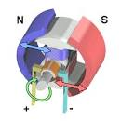

**FIG 1 (b): DC MOTOR (Internal parts)**

**2) ARDUINO UNO**

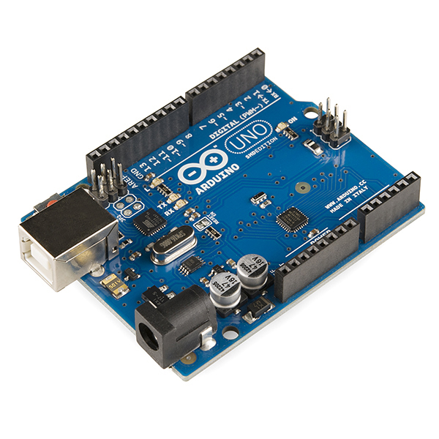

**FIG 2 (a): ARDUINO UNO**

Arduino Uno is an ATmega328P open source microcontroller board developed by Arduino.cc. The instrument panel is equipped with a set of digital and analog I / O pins that can be connected to some expansion boards (shields) and other circuits.

The development panel contains 14 digital I / O ports (six can output PWM), and 6 analog I / O ports, and can be programmed through Arduino IDE (Integrated Development Environment) through a USB Type-B cable, or via a USB battery cable External 9 volts, although it can accept voltages between 7 and 20 volts. It is some were similar to Arduino Nano and also Leonardo.

Material reference design is distributed under an ingenious Commons Attribution Share-Alike 2.5 license and might be found on the Arduino website. Planning and production documents may also be used for specific versions of the fabric.

The word "uno" means "one" in Italian and was chosen because the original version of the Arduino program. Is Uno the primary in a very series of USB-based Arduino boards?] Arduino IDE 1.0 is that the reference version of Arduino and has now evolved into a more modern version. ATmega328 is pre-programmed on the board with a boot loader that may send new code thereto without the utilization of external hardware developers.

The Arduino project started in Ivrea (IDII), Interaction Design Institute, Ivrea, Italy. At the time, students used the BASIC Stamp microcontroller, which was a large fee for many students. In 2003, Hernando Barajan created the wire development platform for the IDII graduate thesis project, which was implemented under the supervision of Massimo Banzi and Casey Rias, and they are known for their editing languages. The purpose of this project is to create simple, low-cost tools for non-engineers to create digital projects.

But instead of continuing with the wiring work, they commissioned the project and renamed it Arduino. The first Arduino cards used FTDI USB for Serial Driver chips and ATmega168. Uno is different from all previous motherboards, it has ATmega328P controller and ATmega16U2 (Atmega8U2 to R2) USB serial adapter.

The wire platform consists of an electrical printed circuit (PCB) with ATmega168 controller, the IDE relies on editing and library functions, and will program the microcontroller easily.

### **General pin functions:**

**• LED indicator:** There is a built-in LED indicator removed from the digital end 13. When the pin is high, the LED indicator lights up; when the pin is low, it turns off.

• **VIN:** When using an external power source, the input voltage of the Arduino / Genuino development board (as opposed to 5 volts from a USB connection or other adjustable power source). You can save voltage through this pin, or if you supply the voltage through a power outlet, you can access it through this pin.

• **5 V:** This adjustable 5-pin pin extracts from the regulator on the board. The board can be powered by DC socket (7-20V), USB socket (5V) or VIN pin (7-20V) for the board. The voltages supplied via the 5V or 3.3V pin will exceed the regulator and the circuit board may be damaged.

• **3V3:** 3.3V power generated by the built-in voltage regulator. The maximum current consumption is 50 mA.

• **GND**: Ground Pin.

• **IOREF:** This Arduino / Genuino pin provides reference voltage for the microcontroller operation. The correct shielding layer design can read the voltage at the IOREF pin and select the appropriate power source, or allow the voltage transformer at the output to operate at 5V or 3.3V. Reset: Usually used to add the back button to protect things on the board.

• **RESET:** Usually used to add the back button to protect things on the board.

### **Special pin functions:**

Uno 14 digital and 6 analog pins is used for input or output under program control (using pin function), digital recording () & and digital reading () working at 5 volts. Each pin can provide or receive 20 mAh as the recommended working condition and has an internal fastening resistance of 20-50 km (by default, it is divided). Any I / O station should not exceed 40 mA max to avoid permanent damage to the microcontroller. Uno has 6 analog inputs called A0 to A5. Each provides 10-bit precision (i.e. 1024 different values). By default, actually the measurement range is from ground to 5 volts, but the upper bound of the range can be definitely changed using the AREF pin and the Analog Reference () function.

In addition to this, some pins also have special functions:

• **Serial / UART:** Used to receive (RX) and send TTL serial data. These pins are attached to the pins corresponding to the ATmega8U2 USB-to-TTL serial chip.

• **External interrupt:** pins 2 and 3. These pins can be configured to create interruptions when they are low, up, down, or change in value.

• **PWM**: pins 3, 6, 5, 10, 9, and 11. PWM output can provide 8-bit with AnalogWrite () function.

• **SPI (Serial Terminal Interface):** pins 10 (SS), 11 (MOSI), 12 (MISO), and 13 (SCK). These pins support a SPI connection using the SPI library.

**• TWI / I²C:** SDA (A4) Pin and SCL Pin (A5). Support for TWI connections using the Wire Library.

• **AREF (analog reference):** reference voltage of the analog input.

**Communications:**

Arduino Uno contains many tools for communicating with the computer, another Arduino / Genuino development board or another microcontroller. ATmega328 provides UART TTL (5V) serial communication, which can be used in 0 (RX) and 1 (TX) digital pins. ATmega16U2 on the board sends this serial connection via USB and displays it as the default software port on the computer. However, in Windows, an .inf file is required. Arduino (IDE) has a serial display that allows you to send simple text data between forms. When transferring data via USB to the serial chip and USB connection to the computer, the RX and TX indicators on the board will flash (but not for serial connections over the years 0 and 1). The serial programs library allows serialization.

3) LCD 16*2

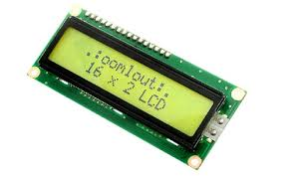

**FIG 3(a): LCD 16*2**

The LCD screen (liquid crystal display) is an electronic display unit with a wide range of applications. 16 x 2 LCD screen is a very basic unit and is often used in various devices and circuits. A 16 x 2 LCD screen indicates that each line can display 16 characters, and there are two lines. The term LCD refers to a liquid crystal display screen. It is an electronic display unit widely used in various applications, such as different circuits and devices, such as mobile phones, calculators, computers, televisions, etc. These screens are mainly used for multi-section and seven-section LED lights. The main benefit of using this unit is its low price. Simple, programmable animation design, no restrictions on the appearance of custom characters, special animations or even animations.

• **Pin 1 (Ground Pin / Source)**: This is usually the GND display pin, which is a common connection to the GND pin of the microcontroller or power source.

• **Pin2 (VCC / Pin pin):** The power supply pin is usually on the screen voltage and is usually connected to a pin that supplies the mounting source.

• **Pin3 (V0 / VEE / Pin)**: This pin can adjust screen difference, a common connection that can provide POT variable from 0 to 5V.

• **Pin4 (Recording / Control Pin Selection)**: This pin alternates between commands or data directories and is used to connect the exact console terminals and obtain 0 or 1 (0 = data mode and 1 = command mode).

• **Pin5 (read / write / control pin)**: This pin switches the screen between reading or writing functions and connects to the microcontroller pin causing 0 or 1 (0 = recording mode and 1 = reading function).

• **Pin 6 (Enable / Control Pin)**: This terminal must be high to perform the read / write operation and be connected to the microcontroller and be high.

• **Pin 7-14 pins (data pins)**: These pins are used to send data to the screen. These pins are connected to a two-wire mode, such as 4-wire operation and 8-wire operation. In 4-wire mode, only four pins are connected to the microcontroller from 0 to 3, while in the 8-wire mode, there are 8 pins connected to the microcontroller from 0 to 7.

• **Pin15 (LED + ve pin)**: This device is connected to + 5V.

• **Pin 16 (pin of valve)**: This device is connected to GND.

**Features of 16*2:**

**Features of the LCD includes the following**:

• The operating voltage of this LCD is 4.7V-5.3V.

• Includes two strings, each string can produce 16 characters.

• 1mA current without backlight.

• You can create each letter using a 5 by 8-pixel stroke. LCD letters and numbers.

• The screen can operate in two modes, such as 4-bit and 8-bit.

• These are available in blue and green backlights.

• Display some custom characters.

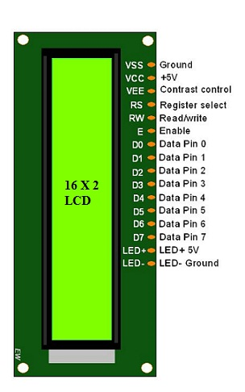

**FIG 3(b): LCD Pin Diagram**

**4) CURRENT SENSOR – ACS712**

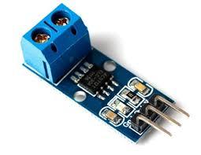

**FIG 4(a): Current Sensor- ACS712**

ACS712 is a fully integrated linear hall effect dependent room sensor, with 2.1kVRMS voltage isolation and a built-in low-resistor. In addition to technical terms, it is simply expressed as a current sensor that uses its conductors to calculate and measure the amount of current applied.

**The features of ACS712 current sensor are as follows:**

• 80 kHz bandwidth Output sensitivity 66 to 185 mV / a.

• Low noise analog path.

• Set the device bandwidth with the new filter pin.

• The resistance of the inner pipeline is 1.2 m Ω.

• When TA = 25 ° C, the resulting total error is 1.5%.

• Constant voltage output switch. Slowdown is almost zero.

**How does the ACS712 power sensor work?**

Now that we understand the functions of ACS712, let's take a look at how it works. Well, in terms of how the power sensor works, this can be done by direct or indirect detection. For ACS712, indirect detection is used. For direct detection current sensors, Ohm rule applies to voltage measurement when current is detected.

**How ACS712 (Simplified) works:**

• The current flows to the IC through the built-in room sensor circuit.

• The room impact sensor detects incoming current by generating a magnetic field.

• Once discovered, the room effect sensor generates a voltage proportional to the magnetic field, which is then used to measure the amount of current.

**ACS712 current sensor application:**

We have created an overview of existing sensors previously applied. Therefore, with ACS712 IC being able to detect AC / DC currents, it can be used not only in electronic devices, but also in a wider range of applications. Whether using Arduino precision controllers / or other industrial, commercial and communications applications, they can be considered suitable.

**The common list of applications:**

• Engine speed control in the engine control circuit.

• Detection and management of fees.

• AC Power Supply (SMPS).

• The current protection is very large.

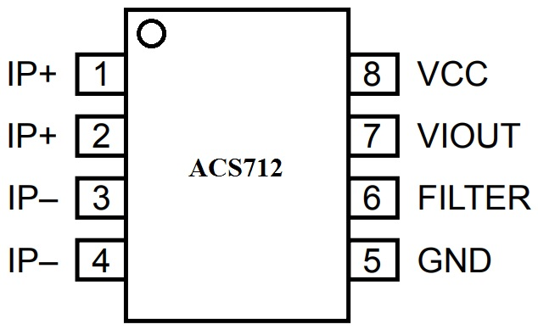

**FIG 4(b): Current sensor pin diagram.**

**5) 5K OHMS POTENTIOMETRE**

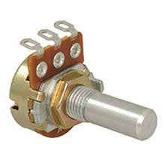

**FIG 5(a): 5K Ohms Potentiometer.**

Potentiometer is a three-way resistor with sliding or rotating contacts, which can form an adjustable voltage divider. If only two ends are used (one end and click), it is used as a variable or capacitor resistor. A measuring instrument called a potentiometer is basically a voltage divider used to measure the electrical voltage (voltage); this component is an implementation of the same principle, so it is called that way.

Potentiometers are commonly used to control volume control in electrical equipment, such as acoustic equipment. Mechanical potentiometers can be used as inverters, for example in control units. Voltage gauges are rarely used for direct control of greater energy (more than 1 W) because the energy consumption of the potentiometer is comparable to that of the controlled load.

The potentiometer includes a sturdy element, a sliding contact (mop) that moves along the element, maintains good electrical contact with part of the element, electrical terminals at both ends of the element, and a method for moving the tap from one end to the other foundations. , And overnight filter and wipe elements.

See the plan. Many cheap potentiometers are made of durable (B) shaped components in a round arc, usually less than a full circle.

Upon rotation, the swab (C) slides on this element, forming an electrical connection. The durable element can be flat or angled. In this case, each end of the resistor is connected to the terminal (E, G). The windshield wiper is usually connected to the third terminal (F) between the other two terminals. On the potentiometer plate, the windshield wiper usually has three central stations. For unidirectional potentiometers, the tap usually turns around the contact once. The only entrance to the infection is the narrow space between the columns.

Another type is the linear sliding potentiometer, which has a windshield wiper that glides along the linear element without spinning. Infection can enter anywhere along the container on which the regulator moves, making effective sealing more difficult and endangering long-term reliability. One of the advantages of the scroll bar potentiometer is that the slider position can intuitively indicate its adjustment. Although you can see the revolving potentiometer adjustment from the position marked with the button, many officers can give an optical impression, for example, the result of a multi-region equalizer (hence the name "graphic equalizer").

The durable components of inexpensive potentiometers are usually made of graphite. Other materials used include resistance wires, carbon particles in plastics, and ceramic / metal mixture called tiles. The conductive potentiometer follows a conductive polymer-resistant paste, which contains solid resins, polymers, solvents and lubricants in addition to carbon that provides conductive properties.

Potentiometers are rarely used for direct control of large amounts of energy (about 1 W). Instead, it is used to adjust the level of analog signals (for example, volume control of audio equipment) and as control entries for electronic circuits.

Pre-defined potentiometers are widely used in all electronic products and should be adjusted during manufacture or maintenance. User-activated potentiometers are widely used as user control components and can control a variety of device functions. Voltage gauge usage has decreased widely in consumer electronics products in the 1990s, and rotary codecs, up / down buttons and other digital consoles are now more popular. However, it is still in many applications, such as power controllers and position sensors.

6)POWER SUPPLY

A power supply is an electrical device that supplies electrical energy to an electrical load. The primary function of the power supply is to convert the current from the source to the correct voltage, current and frequency. As a result, the power supply is sometimes called electric power converters. Some power supplies are separate standalone devices, while others are built into powerful loading equipment. Second examples include power supplies found on desktop computers and consumer electronics. Other functions that can be supplied to a safe level are to limit the current drawn by the load, shut off the electrical current in the event of a fault, electrical conditioning to prevent electronic noise, or the voltage surge in the input to prevent the load from reaching, power-factor correction, and storing energy so that it can power the load during a temporary interruption in the source energy.

**Types of power supply:**

DC power supply:

DC power supply means it supplies a constant DC voltage to its load. Depending on its design, DC power supply can be run from a DC source or from an AC source such as power mains.

AC-to-DC supply:

Schematic of the original AC-to-DC power supply, transformer, full-wave bridge rectifier, filter capacitor and resistor load.

The DC power supply uses the AC main power source as an energy source. Such power supplies utilize a transformer to convert the input voltage to a high or low AC voltage. The rectifier is used to convert the transformer output voltage to a different DC voltage, transmit it through an electronic filter and convert it to an arbitrary DC voltage.

The filter removes most, but not all, AC voltage variations; The remaining AC voltage is called the fluctuation. The fluctuating tolerance of the electric load dictates the minimum amount of filtering that must be provided by the power supply. In some applications, high fluctuation is tolerated and therefore no filtering is required. For example, in some battery charging applications it is possible to operate a main-powered DC power supply that is nothing more than a transformer and a single rectifier diode, with a series resistor on the output to limit the charging current.

Switched-mode power supply:

In a switched-mode power supply, the AC main input is directly corrected and then filtered to get the DC voltage. As a result, the DC voltage is turned on and off at high frequency by an electronic switching circuitry, thus producing an AC current that passes through a high frequency transformer or inductor. Switching occurs at very high frequencies, which enables the use of smaller, lighter and less expensive transformers and filter capacitors than those found in linear power supplies operating at the main frequency. After the inductor or transformer secondary, the high-frequency AC is corrected and filtered to produce a DC Output Tutorial Voltage If the SMPS uses an adequately sorted high-frequency transformer, the output is separated from the main; This feature is often required for safety.

Switched-mode power supplies are usually regulated, and to maintain the voltage throughput voltage, the power supply uses a feedback controller that monitors the load-drawn current. Switching duty cycle increases as power generation requirements increase.

AC power supplies:

The AC power supply usually takes the voltage off the wall and uses the transformer to increase or decrease the voltage to the desired voltage. Some filtering may also take place. In some cases, the original voltage is the same as the tutorial voltage; This is called the Isolation Transformer. Other AC power supply transformers do not provide main isolation; These are called Autotransformers; The variable output autotransformer is called a variable. Other types of AC power supplies are designed to provide steady current, and the voltage throughput can vary depending on the load resistance. When the power source is a direct current, as an automobile storage battery), can be used to convert an inverter and step-up transformer to AC power. Portable AC power can be supplied by a diesel or gasoline engine alternator (for example, in a construction site, automobile or boat, or for backup power generation for emergency services). Some type of AC power converter does not use a transformer. If the input voltage and the input voltage are the same, and the primary purpose of the device is to filter the AC power, it can be called a line conditioner. If the device is designed to provide backup power, it can be called a seamless power supply. That circuit may be degenerated with that voltage multiplier topology to direct step-up power formerly such application was that vacuum tube AC/DC Receiver.

In modern usage, the AC power supply can be divided into a single phase and three phase system. "The primary difference between single phase and three phase AC power is the stability of the distribution." AC power supplies can also be used to change frequency and voltage, often used by manufacturers to test the suitability of their products for use in other countries. Avionics testing is 230 V 50 Hz or 115 60 Hz or 400 Hz.

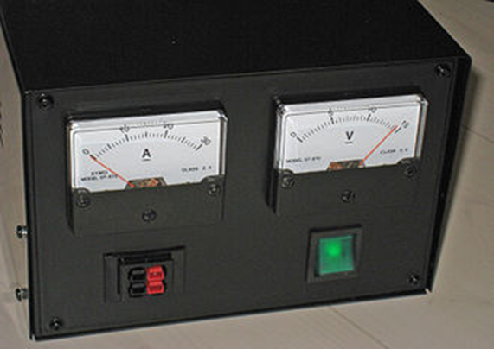

7.) CONNECTING WIRES:

The wire is a single, usually cylindrical, flexible thread or metal rod. Wires are used to carry mechanical loads or electrical and telecommunications signals. The wire is usually formed by drawing the metal through the hole in the die or draw plate. The wire gauges come in various standard sizes as expressed in terms of gauge number. Like "multistrand wire", the term 'wire' is more loosely used to refer to a bundle of such threads, more properly called a wire rope or an electrical cable in mechanics.

The wire comes in solid core, pulled or braided forms. Although generally circular in cross-section, the wire can be made for square purposes such as square, hexagonal, flat rectangular or other cross-sections for decorative purposes, or for high efficiency sound coils in loudspeakers. Edge-wound, coil springs, such as a slinky toy, are made of special flat wire.

The most important property of a wire is its pike constant: a measure of the maximum current passing through a particular cross-sectional area of ​​a wire object. Often attributed to conductive metals such as copper, it is often used by professionals such as electrical engineers.

**Forms of wire:**

Solid wire:

Solid wire, also known as solid-core or single-strand wire, consists of a piece of metal wire. Solid wire is useful for wiring breadboards. Solid wire is cheaper to make than wire and is used where the wire does not require flexibility. Solid wire also provides mechanical roughness; And, because of its relatively low surface area, it is exposed to corrosive attack, providing protection against the environment.

Stranded copper wire:

Stranded wire is composed of several small wires or wrapped together to form a large conductor. Stranded wire is more flexible than solid wire of the same total cross-section. Stranded wire is used when high resistance to metal fatigue is required. Such scenarios include connections between circuit boards in multi-printed-circuit-board devices, where solid wire stiffness causes excessive pressure as a result of movement during assembly or service; For equipment Line ropes; Musical instrument cables; Computer mouse cables; Welding electrode cables; Control cables connecting moving machine parts; Mining machine cables; Backward machine cables; And several others.

At high frequencies, the electrical effect of the skin moves near the surface of the wire, resulting in a loss of power in the wire. Stranded wire seems to reduce this effect because the total surface area of ​​the strands is greater than the surface area of ​​the equivalent solid wire, but the normal strand wire does not reduce the effect of the skin because all strands are short-circuited and act as a single conductor. The stranded wire has greater resistance than the solid wire of the same diameter because the cross-section of the stranded wire is not all copper; There are unavoidable gaps between the threads (this is the circle packing problem for circles within the circle). The strand wire having the same cross-section of the conductor as the solid wire has the same magnitude and is always the largest diameter.

However, for high frequency applications, the proximity effect is more severe than the skin effect, and in some limited cases, a simple strand wire reduces the proximity effect. For better performance at higher frequencies, separate threads into separate samples and use twisted Litz wire.

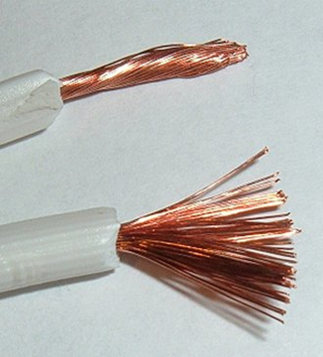

Stranded copper wire

Prefused wire:

Prefused wire is a threaded wire that is much taller and then fused together. Prefabricated wire has many characteristics of solid wire, except that it is less likely to break.

Braided wire:

Braided wire Several small strands of wire are woven together. Braided strings do not break easily when bent. Braided wires are well suited as an electromagnetic shield in noise-reduction cables.

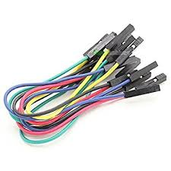

            Connecting wires

8.) DC-DC BOOSTER:

The Boost converter will be powered by any suitable DC source, like batteries, solar panels, rectifiers, and DC generators. The method of converting one DC voltage to a unique DC voltage is named as DC to DC conversion. The amplifier converter is a DC to DC converter with output voltage more than the initial voltage. A boost converter is typically called as step-up converter because it "steps up" the initial voltage. Since the power ({\ display style P = VI} P = VI) must be conserved, the current output current is smaller than the initial current.

The Boost converter can be powered by any suitable DC source like batteries, solar panels, rectifiers, and DC generators. The method of converting one DC voltage to a different DC voltage is named as DC to DC conversion. The amplifier is a DC to DC converter with output voltage higher than the original voltage. A boost converter is sometimes named as step-up converter because it "steps up" the original voltage. Since the power must be conserved ({\ display style P = VI} P = VI), the current output current is less than the source current.

**Applications:**

* Low-Cost Converter Modules: Two Buck and One Boost.
* Battery power systems usually attach cells in series to achieve high voltage. However, insufficient assembly of cells is not possible in most high voltage applications due to lack of space. Boost converters can increase the voltage and reduce the number of cells. Two battery powered applications that use boost converters are used in hybrid electric vehicles (HEVs) and lighting systems.
* N NHW20 model Toyota Prius uses HEV 500 V motor. Without a boost converter, the Prius needs about 417 cells to power the motor. However, the Prius actually only uses 168 cells [citation needed] and increases the battery voltage from 202 V to 500 V. Boost converters also power devices in a small number of applications, such as portable lighting systems. The white LED usually requires 3.3 V to emit light, and the boost converter increases the voltage from a single 1.5 V alkaline cell to energize the lamp.
* An uncontrolled boost converter is used as a voltage boosting mechanism in a circuit known as a 'joule blower'. This circuit topology is used with low power battery applications, and is aimed at the ability of the boost converter to 'steal' the remaining energy in the battery. This energy is wasted since the low voltage of the nearly depleted battery cannot be used for normal load. This power is unpaid because many applications do not allow enough current to flow through the load when the voltage is low. This voltage decrease is due to the depletion of batteries and is a characteristic of the ubiquitous alkaline battery. Since the energy equation ({\ display style P = V {{2} / R} P = V {{2} / R), and R is constant, the power available to the load decreases significantly as the voltage decreases.

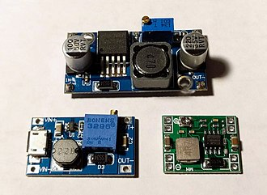

9.) PVC PIPES:

A plastic pipe is a tubular section, or hollow cylinder, made of plastic. It is commonly used to convey circular cross-sectional, mainly flowable materials — liquids and gases (liquids), slums, powders, and small solids. It can also be used for structural applications; The hollow tubes are much firmer per unit weight than the solid members.

Plastic pipework is used for drinking water, waste water, chemicals, heating and cooling fluids, foodstuffs, ultra-pure liquids, slums, gases, compressed air, irrigation, plastic pressure pipe systems and vacuum applications.

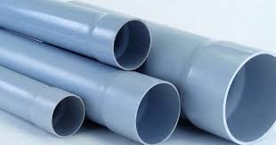

PVC pipes

10.) VOLT METER:

A voltmeter is a device used to measure the electrical potential difference between two points in an electrical circuit. Analog voltmeters move the pointer on a scale corresponding to the voltage of the circuit; Digital voltmeters provide numerical display of voltage by using analog to digital converter.

Voltmeters are manufactured in a wide range of styles. Permanently attached tools on the panel are used to monitor generators or other stationary equipment. Portable equipment, usually equipped with a mustimeters format to measure current and resistance, are standard test equipment used in electrical and electronics work. Any measurement that can be converted to voltage can be displayed on an appropriately calibrated meter; For example, pressure, temperature, flow or level in a chemical process plant.

General-purpose analog voltmeters may have a certain percentage of full accuracy, and are used with voltages ranging from one part of a voltage to several thousand volts. Digital meters can be made with high accuracy, usually better than 1%. Particularly calibrated test equipment has high accuracy, and laboratory equipment is capable of measuring the accuracy of parts per million. Meters that use amplifiers can measure smaller voltages of microvolts or less.

Part of the problem with making an accurate voltmeter is calibration to test its accuracy. In laboratories, the Weston cell is used as a standard voltage for precision work. Accurate voltage references are available based on electronic circuits.

**Analog voltmeter:**

A moving coil galvanometer can be used as a voltmeter by inserting a resistor in series with the instrument. The galvanometer has a fine wire coil suspended in a strong magnetic field. When electric current is applied, the interaction of the coil's magnetic field and the stationary magnet creates torque, causing the coil to rotate. The torque is proportional to the current through the coil. The coil rotates, compressing the spring to resist rotation. The deflection of the coil is proportional to the current, which is proportional to the applied voltage, denoted by a pointer.

One of the design objectives of the instrument is to disturb the circuit as little as possible and therefore draw the minimum current for the instrument to operate. This is achieved by using a series of sensitive galvanometers with high resistance, and then connecting the entire apparatus to the tested circuit.

The sensitivity of such a meter can be expressed as "Ohm per volt", the number of Ohms resistance in the meter circuit can be divided by the total measured value. For example, a meter with a sensitivity of 1000 ohms per volt draws 1 milliampere at full voltage; At full voltage of 200 volts, the impedance at the instrument terminals is 200000 ohms and draws 1 milliampere from the full scale meter circuit test.

For multi-array devices, the input impedance changes as the instrument is moved to differentiers. Moving-coil equipment with a permanent magnet field only responds to direct current. Measurement of the AC voltage requires a rectifier in the circuit so that the coil turns in only one direction. Some moving-coil equipment is made with zero position in the middle of the scale instead of one end; These are useful if the voltage reverses its polarity.

Voltmeters working on the electrostatic principle use the mutual repulsion between two charged plates to rotate the pointer attached to the spring. These types of meters draw negligible current but are sensitive to voltages of more than 100 volts and can operate with alternating or direct current.

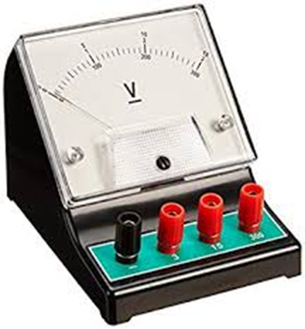

              Analog voltmeter

**Digital voltmeter:**

Two digital voltmeters. Note the 40-microvolt difference between the two measurements, an offset of 34 parts per million.

The Digital Voltmeter (DVM) measures the unknown input voltage by converting the voltage to a digital value and then displaying the voltage in numerical form. DVMs are designed around a special type of analog-to-digital converter, commonly called a converter.

DVM measurement accuracy is influenced by many factors, including temperature, input impedance and DVM power supply voltage variations. Less expensive DVMs usually have input impedance in the order of 10 MΩ. Accurate DVMs can have an input resistance of 1 G Ω or greater for low voltage ranges (e.g. less than 20 V).To ensure that the accuracy of the DVM is within the manufacturer's specific tolerances, it must be calibrated periodically to a voltage standard such as a Weston cell.

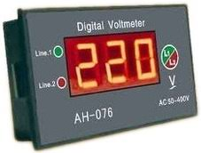

                        Digital voltmeter

11.) BLADES:

The ratio between blade tips and wind speed is called the tip speed ratio. High-efficiency 3-blade-turbines have terminal speed / wind speed ratios of 6 to 7. Modern wind turbines are designed to rotate at different speeds (the effect of their generator design, see above). Their blades use aluminium and composite materialslow rotational inertia means that new wind turbines accelerate faster when wind is picked up and the tip speed ratio is more stable. Wind turbines improve energy capture with the typical gusto in urban settings as they work close to their optimal tip speed ratio during windsurfing.

In contrast, old-fashioned wind turbines are designed with heavier steel blades, which have higher inertia, and rotate at the speed of the AC wires. High inertia prevents changes in the speed of rotation and thus makes the power output more stable.

It is generally understood that noise increases with higher blade tip speed. Increasing the tip without increasing the noise allows the gearbox and generator to reduce torque and reduce overall structural load, thereby reducing costs. Noise reduction is related to the detailed aerodynamics of the blades, especially the factors that reduce sudden shutdowns. The inability to stall can impede the development of aggressive aerodynamic concepts. Some blades (mostly in Enercon) have a winglet to increase performance and / or reduce noise.

A blade may have a lift-to-drag ratio of 120, compared to 70 for sailing and 15 for aircraft.

Blade materials:

In general, ideal materials must meet the following criteria:

* Wide availability and easy processing to reduce cost and maintenance.
* Light weight or density to reduce gravitational forces.
* Strong loading of air and high strength to withstand the gravitational force of the blade.
* High fatigue resistance to withstand C wheel loading.
* Greater stiffness to ensure optimal shape and orientation of the blade and clearance along the shade border.
* High fracture toughness.
* Lighting Ability to withstand environmental impacts such as lightning strikes, humidity and temperature.



                                 Windmill blades

**B. SOFTWARE DESCRIPTION:**

**ARDUINO UNO**

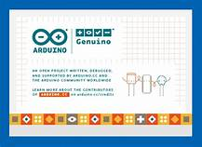

**FIG 6(a): Arduino Software.**

**What is Arduino?**

Arduino is basically an open source platform with easy-to-use programs and programs. The Arduino board can actually read the sensor input light - converting it to engine output playback, LED playback and content posting online. By sending a set of commands to the microcontroller on the motherboard, you will tell the motherboard what to do. For many years, from everyday objects to aristocratic scientific instruments, Arduino has been the mastermind of thousands of works. This open source platform brings together a global community of manufacturers, students, hobbies, artists, developers, and professionals. Their contributions add a lot of information and can greatly help novices and experts.

Arduino was born at the Ivrea Interaction Design School, a fast and easy-to-use original tool, especially suitable for college students without an electronic background and programming. After entering the wider community, the Arduino development team started making changes to adapt to new needs and challenges, and expanded its product range from simple 8-bit tables to 3D IoT applications for portable and compact environmental products. All Arduino development boards are completely open source, allowing users to work independently, and ultimately customize them according to their specific needs. The program is also open source and is developed through contributions from users all over the world.

**Why choose Arduino?**

Arduino is easy to use for beginners, but completely flexible for advanced users. It can be run on Mac, Windows and Linux devices. Teachers and students use it to create low-cost scientific tools to demonstrate the principles of chemistry and physics or start programming and robotics. Designers and architects have created interactive prototypes that musicians and artists can use to try new lighting tools and musical instruments. For example, manufacturers will naturally use them to complete many projects presented in Maker Faire.

Arduino is an important tool for learning new things. Anyone (children, amateurs, artists, and developers) can follow the group's step-by-step instructions or share ideas online with other members of the Arduino community to start playing the game. There are many microcontrollers and other microcontrollers available for computers. Baseband Stamping, Net media BX-24, Phi gets, MIT Handy board, etc. Provide similar functionality. All these tools use messy details to program the microcontroller and package it in a convenient package.

Arduino also simplifies the operation of the microcontroller, but compared to other systems, it provides an advantage for interested teachers, students and hobbyists: Arduino panels are relatively inexpensive compared to other microcontrollers. The cheapest version of the Arduino unit can be manually assembled, and even pre-assembled Arduino (IDE) units that cost less than $ 50 can run on Windows, Macintosh OSX, and Linux. Most control systems are limited to Windows.

Clean, simple& easy programming environment - Arduino (IDE) is easy to use for beginners, but flexible enough to benefit advanced users. For teachers, it correctly relies on the editing programming environment, so students who learn programming in this environment will be familiar with the way the Arduino IDE works. Open Software and Extensible Software - Arduino is released as an open source tool and can be expanded by experienced developers.

The language can be expanded through the C ++ library, and people who want to know the technical details can change from Arduino to the AVR C programming language. Likewise, you can add the AVR-C code directly to Arduino as needed. Arduino circuit board design icon is open source and expandable devices have a knowledge sharing license, so experienced circuit designers can create their own unit versions for expansion and improvement. Even relatively inexperienced users can create versions of operating systems to understand how they work and save money plus this is an incredible software for creation.

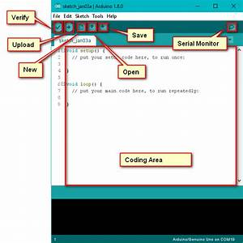

**FIG 6(b): Arduino Software (description).**

**CHAPTER 6**

RESULT AND DISCUSSION

Wind energy is converted to electrical energy, current generated is observed through LCD screen.   
Phone is charged from the power generated.   
The microcontroller can accurately measure the output voltage of the generator and correlate that measurement with the wind speed and display it on an LCD screen. Additionally, the microcontroller can supply 5V to components in the control circuit.

**CHAPTER 7**

ADVANTAGES AND APPLICATION

Advantage

• It generates more power

• It is not necessary connect the same generator and also connect different generator in serious shaft

• We will use all type of generators like permanent magnet D.C. generator, synchronous generator and induction generator

• Gear box is not used, only two straight bevel or spiral bevel gear is used (driver and driven gear)

• The power output is double compare to single windmill.

Limitations

Initial cost is high

• Efficiency low .

• Maintenance is important and high

• Design is complement for gear and rotor turbine

• It require lot of space

Applications

Application is to provide electricity to house and industry.

**CHAPTER 8**

FUTURESCOPE

Our future work includes better integration of components, reduced turbine weight and increased efficiency of the units that make up the system. The turbine weight can be reduced by reducing the mechanical design. With lighter parts, the gearbox can be easily simplified to take less space, generate less drag and be lighter. When the size of some parts is too large, the efficiency of the electronic power source can be improved. In addition, safety features such as braking and locking can be combined to make the portable wind turbine more flexible. This model can go far beyond charging methods for laptops, luxury car audio systems, lighting technology, etc. The system can also be applied to trains, so high-speed rail movement can be used to generate useful electricity.

**CHAPTER 9**

CONCLUSION

We suggest an alternative way to charge mobile devices on the go. We have created a powerful turbine that can generate energy and withstand high wind speeds. The transformer can accept input from 1 to 18 volts and output fixed voltage 5 volts, thus reducing ripple and getting high performance. The control circuit can output the PWM, and if it deviates from the required PWM, it will correct the output. The microcontroller can accurately measure the output voltage of the generator and link this measurement result to wind speed and display it on the LCD screen. In addition, it can provide 5V controller for the components in the control circuit.

REFERENCES

1] M. Ragheb, “Vertical Axis Wind Turbines”, University of Illinois at Urbana-Champaign, March 2015

[2] F. Sigernes, “Draft: Savonius Wind wind rotor basics”, University Centre in Svalbard, Norway, 2015

[3] M. Ragheb, “Vertical Axis Wind Turbines”, University of Illinois at Urbana-Champaign, March 2015

[4] Electronics hub

APPENDIX

#include <LiquidCrystal.h>

LiquidCrystal lcd(7, 6, 5, 4, 3, 2);

const int currentPin = A0;

int sensitivity = 66;

int adcValue= 0;

int offsetVoltage = 2500;

double adcVoltage = 0;

double currentValue = 0;

void setup()

{

Serial.begin(9600);

lcd.begin(16, 2);

lcd.print(" Current Sensor ");

lcd.setCursor(0,1);

lcd.print(" with Arduino ");

delay(2000);

}

void loop()

{

adcValue = analogRead(currentPin);

adcVoltage = (adcValue / 1024.0) * 5000;

currentValue = ((adcVoltage - offsetVoltage) / sensitivity);

Serial.print("Raw Sensor Value = " );

Serial.print(adcValue);

lcd.clear();

delay(1000);

//lcd.display();

lcd.setCursor(0,0);

lcd.print("ADC Value = ");

lcd.setCursor(12,0);

lcd.print(adcValue);

delay(2000);

Serial.print("\t Voltage(mV) = ");

Serial.print(adcVoltage,3);

lcd.setCursor(0,0);

lcd.print("V in mV = ");

lcd.setCursor(10,0);

lcd.print(adcVoltage,1);

delay(2000);

Serial.print("\t Current = ");

Serial.println(currentValue,3);

lcd.setCursor(0,0);

lcd.print("Current = ");

lcd.setCursor(10,0);

lcd.print(currentValue,2);

lcd.setCursor(14,0);

lcd.print("A");

delay(2500);

}